PROJECT DOCUMENTATION
CookBook: Your Virtual Kitchen Assistant.
1. Introduction
• Project Title: CookBook: Your Virtual Kitchen Assistant.
• Team ID: NM2025TMID31293
• Team Leader: Mohamed Abith P – 24cs3226@gmail.com
• Team Members:
- VeeraRaja V& 24cs3252@gmail.com
- Venkatesh Kumar G & 24cs3253@gmail.com
- Vetrivijay A & 24cs3254@gmail.com
2. Project Overview
- Purpose:
"CookBook is your ultimate virtual kitchen assistant, designed to make cooking easier and more enjoyable. With a vast recipe library, meal planning tools, and step-by-step cooking guidance, you'll be whipping up delicious meals in no time. Whether you're a seasoned chef or a kitchen newbie, CookBook is here to help you cook with confidence. Get cooking and make every meal a masterpiece!"
- Goals:
- Centralized Recipe Collection – Provide a digital platform to store and access recipes easily.
- Easy Navigation – Use a clean UI and React Router for smooth browsing between categories and recipe details.
- Learning Support – Integrate YouTube tutorials for step-by-step cooking guidance.
- Category Organization – Group recipes by type (Beef, Chicken, Dessert, etc.) for quick discovery.
- User-Friendly Experience – Design an interface that is simple, responsive, and attractive.
- Reusable & Scalable – Build with React components so new features and recipes can be added easily.

- Key Features:
- Recipe Categories – Browse recipes by popular food categories (Beef, Chicken, Dessert, etc.).
- Recipe Details Page – View ingredients, preparation steps, and video tutorials.
- YouTube Video Embedding – Watch cooking videos directly inside the app.
- Search & Navigation – Quickly find specific recipes using smooth navigation.
- Responsive Design – Works on desktop, tablet, and mobile devices.
- Reusable Components – Built with React components for cards, lists, forms, etc.
- API Integration (if added) – Fetch recipes dynamically using Axios.
- Modern UI – Styled with CSS and React Icons for a professional look.
3. Architecture
- Component Structure
- App.js — Root component, sets up routes and layout.
- Navbar.jsx — Provides site navigation across pages (Home, Categories, Recipes).
- Home.jsx — Homepage container, displays Hero, CategoriesHome, and NewsLetter.
- CategoriesHome.jsx — Shows recipe categories on the homepage.
- Category.jsx — Page that lists recipes filtered by category.
- Recipie.jsx — Page displaying a single recipe with details.
- About.jsx — Static page about the Cookbook application.
- Footer.jsx — Footer with branding, copyright, and links.

- State Management
- Local State: Managed using React useState and useEffect.
- API Integration: Axios used for fetching data from CookBook API & YouTube API.
- Routing
- Library: react-router-dom
- Routes:
- / Home.jsx
- /pages/Category => food Category.jsx
- /category/Recipie ? Recipie.jsx
4. Setup Instructions
Prerequisites
- Node.js & npm
- Node.js is required to run React applications.
- npm (Node Package Manager) is used to install dependencies.
- Download Node.js
- React.js
- React is the main JavaScript library used to build this project.
- If you don’t have an existing React app, create one using:
- npx create-react-app my-app
- cd my-app
- npm start
- In SB Fitzz, the React app is already created, so you just need to install dependencies (npm install).

- Git
- Used for cloning and version control.
- Download Git
- Code Editor
- Recommended: Visual Studio Code (VS Code)
- Download VS Code
- Basic Knowledge
- HTML, CSS, JavaScript
- React concepts (components, props, hooks, state, routing)
- Installation
- Get the code:
- Download the code from the drive link given below:
- https://drive.google.com/drive/folders/1u8PnV_mE0mwKkH_CvuNpliZtRLJZMqrO?usp=sharing
- Install Dependencies:
- Navigate into the cloned repository directory and install libraries:
- Navigate into the cloned repository directory and install libraries:
- cd CODE
- npm install
- Start the Development Server:
- To start the development server, execute the following command:
- npm start
- Access the App:
- Open your web browser and navigate to http://localhost:3000.
- You should see the application's homepage, indicating that the installation and setup were successful.
- Environment Variables
- Create a .env file with:
- REACT_APP_API_URL=<https://exercisedb.p.rapidapi.com/exercises/equipmentList>
- REACT_APP_YOUTUBE_API_KEY=<33cf3a7616msh4c3b1e3204f24e2p1294b3jsne16a7323d732>

5. Folder Structure

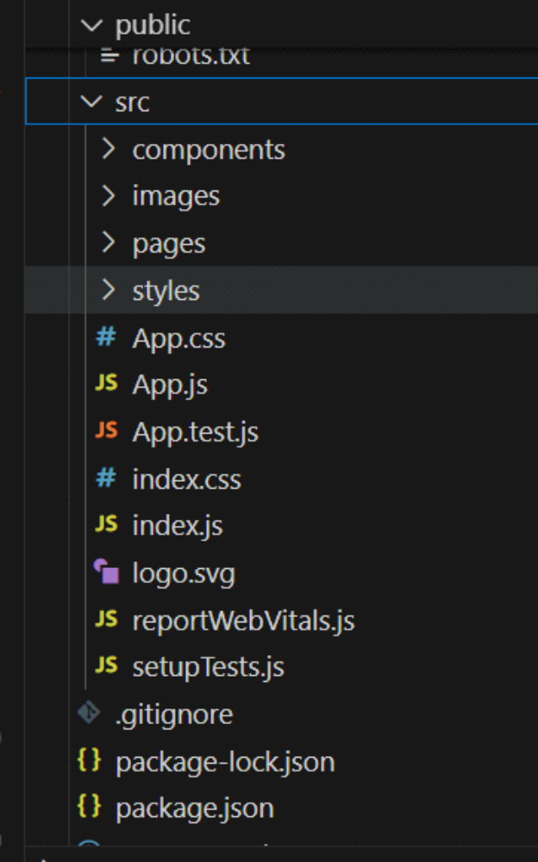

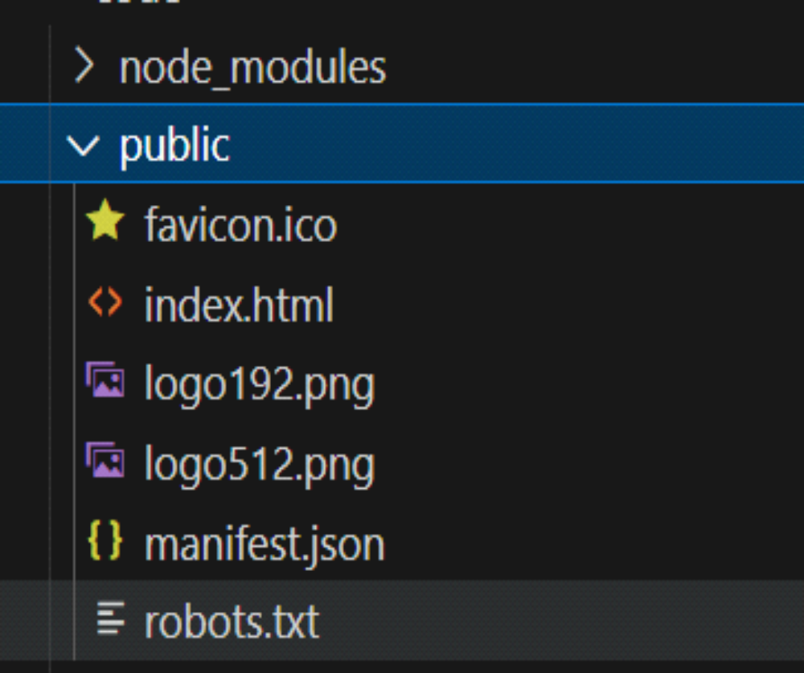

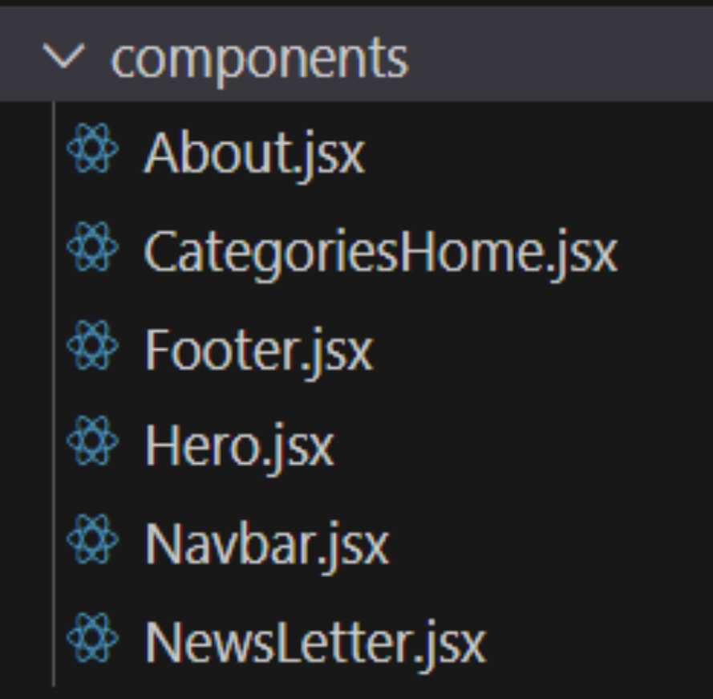

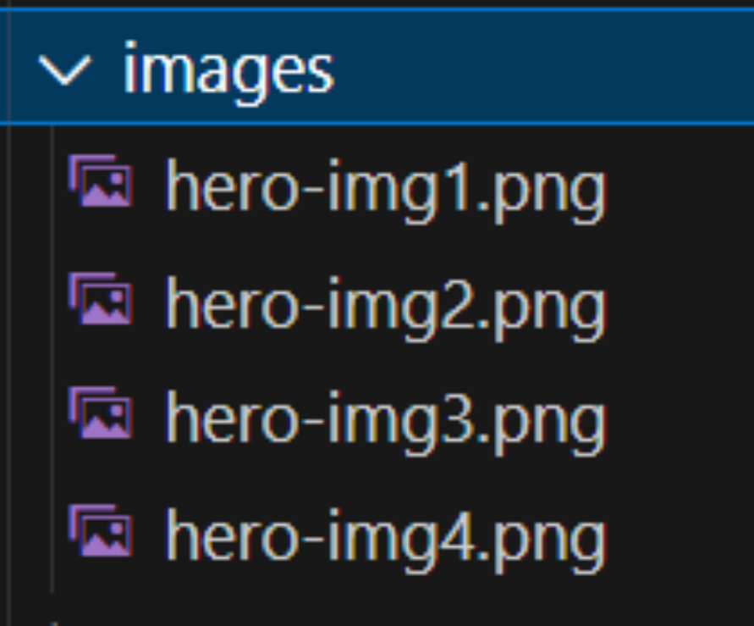

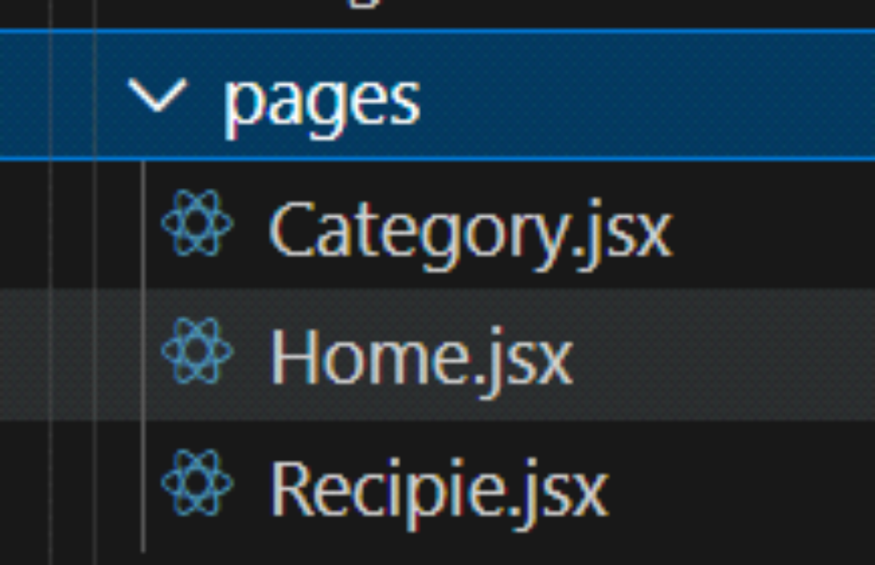
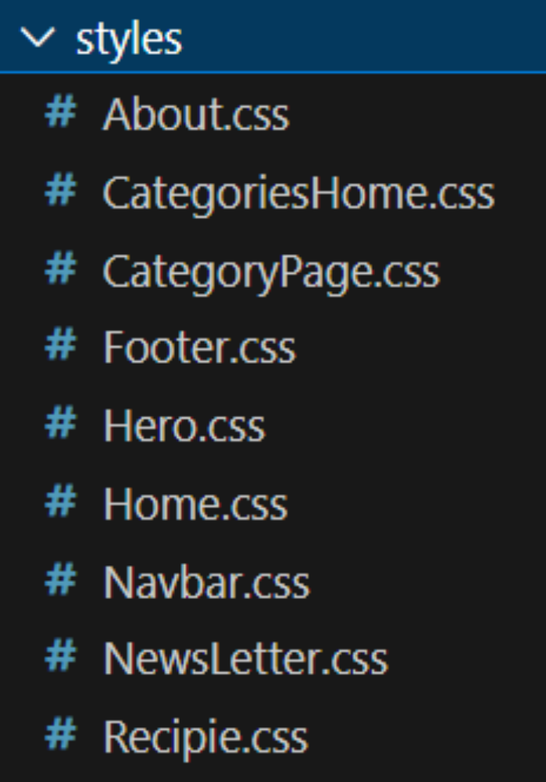

6.Running the Application
- Start development server:
- npm start
- Build for production:
- npm run build
- Run tests:
- npm test

7. Component Documentation
- index.js => renders <App />
- App.js => wraps Navbar, Routes, and Footer
- Home.jsx => (uses Hero, CategoriesHome, NewsLetter)
- category => Category.jsx (may also reuse CategoriesHome)
- Recipie.jsx => (shows details of a recipe)Components import their CSS modules for styling.
- images => used in Hero, Home, and Category pages
8. State Management
- Local State:
- Search queries stored in HomeSearch.
- API data fetched and stored per-page.
- Global State:
- Not implemented — app uses component-level state.
9. User Interface
- Pages include:
- Home (Hero + Search )
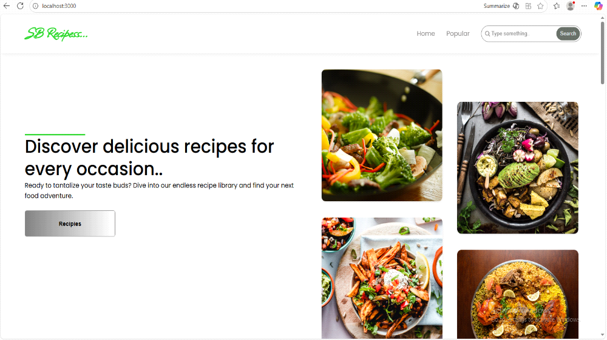
- Popular:
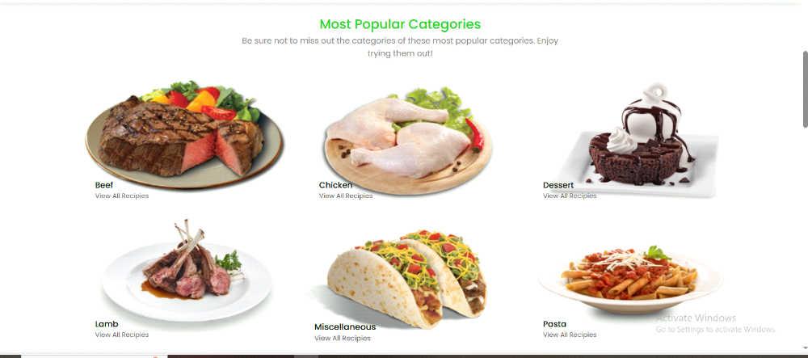

10. Styling
- Frameworks Used: Tailwind CSS / Bootstrap.
- Custom CSS: Stored in src/styles/.
- Each page/component has a dedicated CSS file for modularity.

11. Testing
- Libraries Used: Jest, React Testing Library.
- Unit Tests: Written in App.test.js.
- Setup: Configured with setupTests.js.

12. Screenshots / Demo
Demo Link:
https://drive.google.com/file/d/1xaU310tSFEPipSwtTnT3YAg3SVPQHQFH/view?usp=drive_link

- Screenshot:

13. Known Issues
- API rate-limit may cause some exercises not to load.
- YouTube API sometimes fails to fetch related videos.

14. Future Enhancements
- User Authentication – Allow users to sign up, log in, and save their favorite recipes.
- Recipe Submission – Let users add and share their own recipes with the community.
- Search & Filters – Advanced search by ingredients, cuisine, prep time, or dietary needs.
- Favorites & Collections – Users can bookmark recipes and organize them into collections.

